In the database design, the system stores information about 5 main components which are VIP User, Reservation, Parking area (Zone), Spot and Currently looking. The following figure illustrates the overall Entity Relationship diagram for the system:

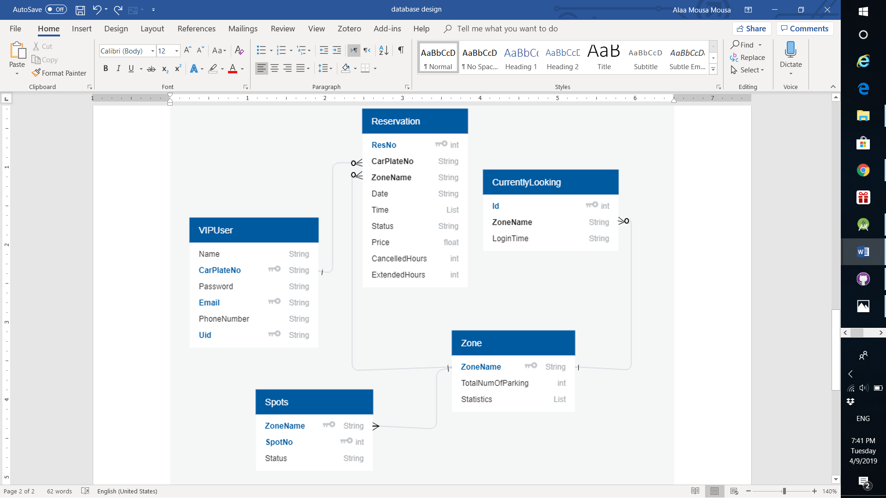

From the above ER diagram, we can figure out the relationships that exist between each two entities:

* VIPUser has zero or many Reservation.
* Each Reservation belongs to one VIPUser.
* Each Reservation is associated with one Zone.
* Zone is associated with zero or many Reservation.
* Zone has zero or many CurrentlyLooking.
* Zone has many Spot.
* Each CurrentlyLooking belongs to one Zone.
* Each Spot is assigned to one zone.